ASSIGNMENT
1) Print the numbers from 1 to 50 which are divisible by 5 using looping statement and display the output
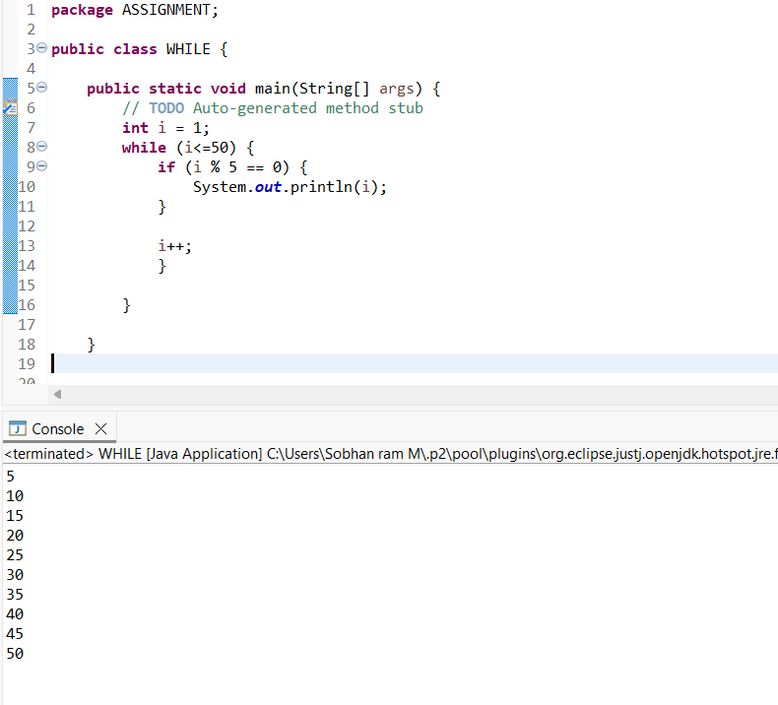

2) Count the odd numbers between 1 to 100 and print
